Onboarding for New Employees

- To begin Onboarding, you should have received a welcome email with a link to the PeopleAdmin Onboarding website. Click on the “Logging in for the first time?” link and enter your email address. The system will send you an email with instructions on setting up your password.

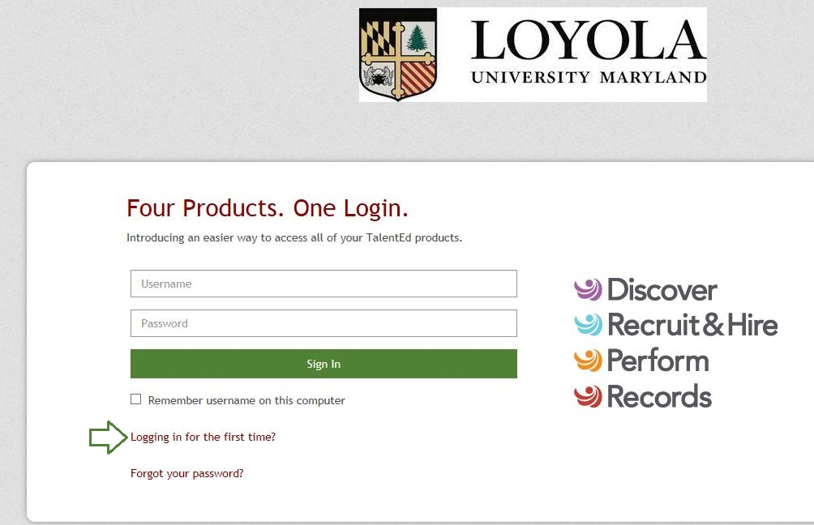

- Once you have logged in you will be taken to the My Tasks page. The My Tasks page is where you can view and complete an outstanding tasks that have been assigned to you. On this page you will have two tabs.

- The first tab will be the “Needs Attention” tab, this tab indicates all items that have been assigned to you that needs an action to be performed on it. To take action on an item click on the View/Mark As Done button to the right of the item.
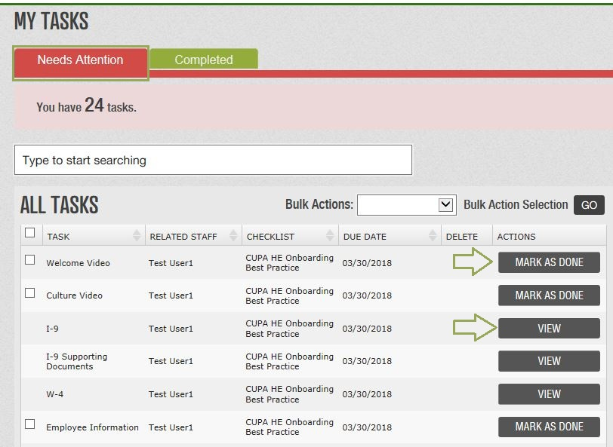

- Some Task will require you to digitally sign prior to completing the form. To sign a form you must first save the form as a final.

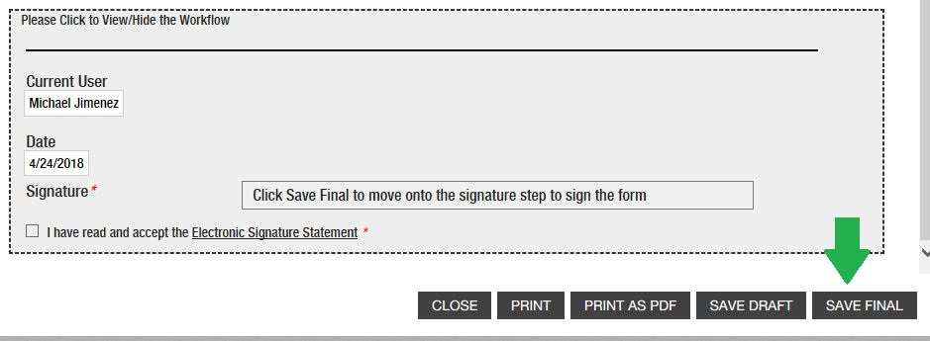

- Once the form has been saved, it will allow you to sign and submit the final document.

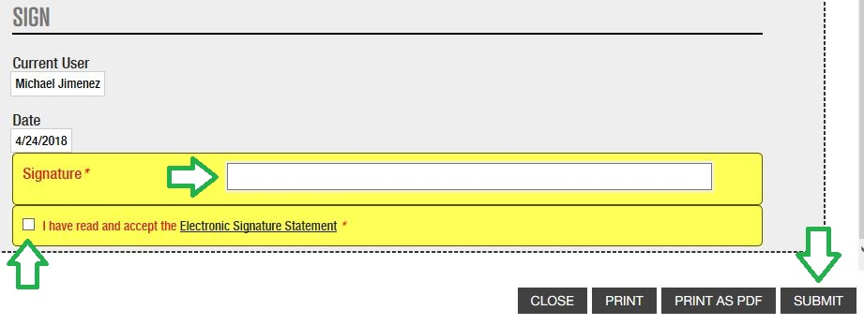

- The second tab will be the “Completed” tab, this tab indicates all items that have been assigned to you and are completed. Keep in mind that tasks may not show up on your “Completed” tab immediately, if they require an additional step by a supervisor or staff member. To review items that have been completed you can click on the View button to the right of the item.
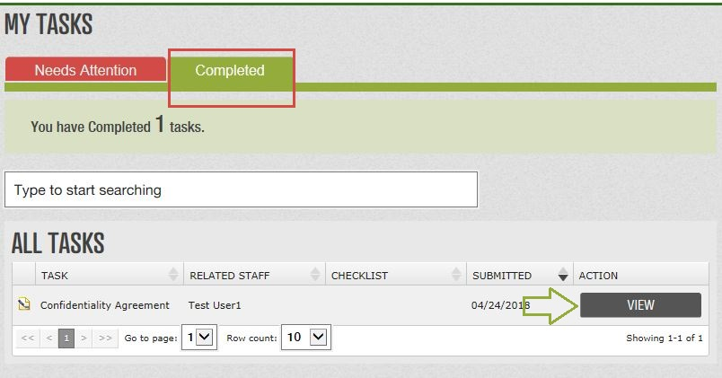

- Certain documents can be completed at any time. These are referred to as Blank Docs. Blank documents can be access through the “Blank Docs” icon located a top right of the screen.

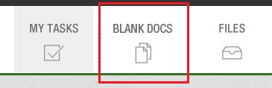

- To complete a Blank Doc, simply open the document you wish to submit, enter the data requested, and Save Final. Your document will automatically route to the appropriate department for processing.
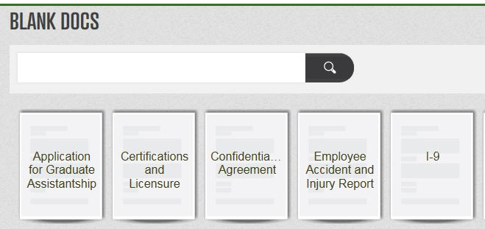

- Documents that have been completed will also be listed on your Files page. You can access the Files page by clicking on the Files Icon on the top right corner of your screen.

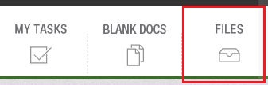

- Documents that you have submitted will be sorted in the appropriate folder and sleeve. As an example, if you have submitted a direct deposit form, it will be filed in the Payroll folder and direct deposit sleeve.

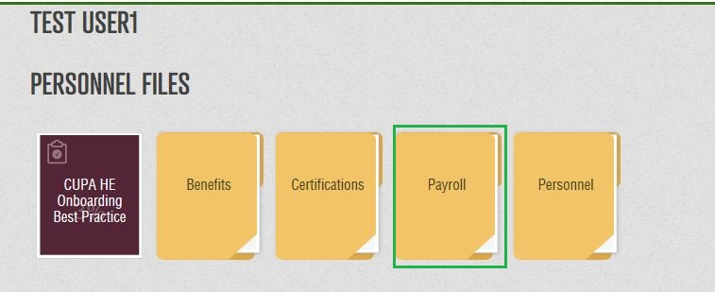

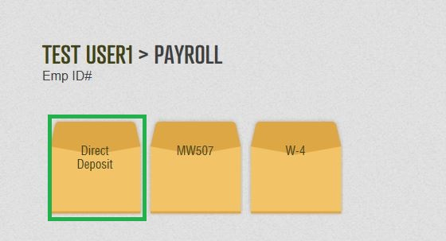

- You can receive one or multiple checklists depending on the position you have received. All checklists that have been assigned will appear on the “Needs Attention” tab. As a new hire the Onboarding process will require you to complete a range of tasks from providing critical employment information, review insurance information, to reading Loyola polices and procedures. Below you will find a list of common forms and their descriptions.

Title | Description
W-4 Form | If no response is received for federal withholdings, defaults will be set as the system indicates.
Maryland State Tax Form | If no response is received for State withholdings, defaults will be set as the system indicates.
Policy Manual | This Staff and Administrators Policy Manual provides information about the terms and conditions of your employment, your responsibilities as a member of the Loyola community, important policies and procedures, and general information about the services, benefits, programs, and facilities related to your employment.
Personal Data Form | This form will collect personal data that was not included in the applicant tracking system. This form will also verify information that was provided.
Confidentiality Agreement | This is an agreement that the employee is responsible to keep all information outlined in the agreement confidential.
Title IX Resource Guide | A guideline for employees to provide an environment free from sex-based discrimination and harassment that complies with the Title IX of Education Amendments of 1972.
Parking Brochure | A brochure outlining Loyola’s parking policy, registration and cost.
Direct Deposit Agreement Form | This form allows new employees to set up direct deposit.
Summary of Employee Benefits Booklet | This booklet provides eligible employees look at all of the medical benefits Loyola University Maryland provides.
HIPPA Notice of Privacy | A Notice of how medical information about you may be used under the Health Insurance Portability and Accountability Act.
HealthCare Exchange Notice | This Notice provides information on the Health insurance MarketPlace and how to obtain additional information.

